TITHELY TUTORIAL

- Go to https://www.stthomaswhitemarsh.org/supportstthomas

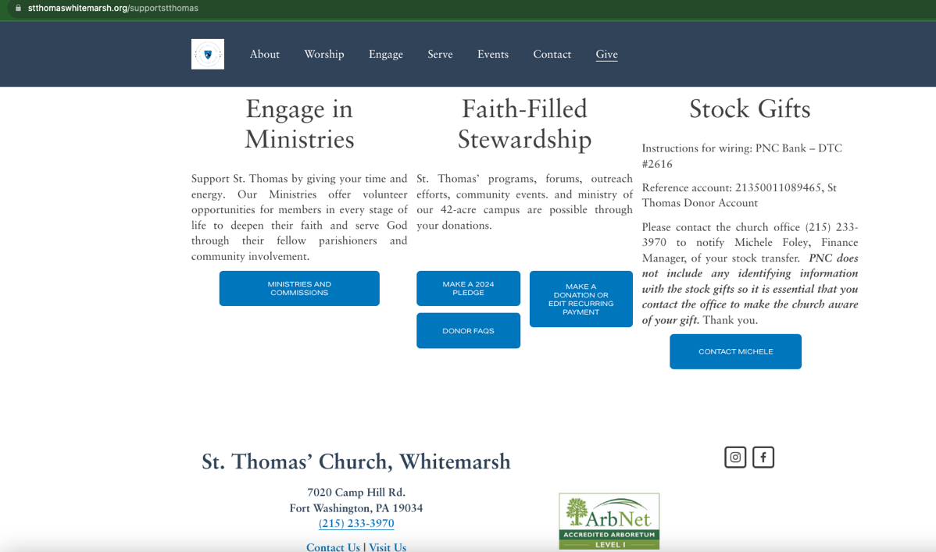

NOTE: If you are using the Tithely app, open Tithe.ly App on your phone. Enter your username and password and click "Log In."
Need to download the App? Click here.

- To make a pledge if you haven’t already (this helps the vestry plan our budget; we highly encourage you to consider making a pledge if you plan to give)
Click: MAKE A 2024 PLEDGE: fill out the info on the form and submit. NOTE: this is only informing us of your planned amount for 2024; it is not actual payment

- To make a donation: Click on MAKE A DONATION OR EDIT RECURRING PAYMENT under Faith-filled Stewardship

- When you see the above screen, click log in or sign up on the top right and log in with your info and pin. If you don’t want to access your account later or are only making a one-time donation, you can skip this step.

- Fill in the amount you want to give, select “pledges” (or “one-time donation”) on the drop-down box, click recurring giving if you would like to set this up, and select how often you want to give. Fill out your financial information (card, bank or google pay), and click the GIVE button.

NOTE 1: if you are setting up recurring payments, the amount you put in GIVE should be your recurring amount, not the total amount. For instance, if you are pledging $1200 for the year, you might select Give: $100, every month on the 1st. This process will automatically draw the funds from the account inputted.
NOTE 2: If you already have a recurring payment set, see the RECURRENT GIFTS below.

- If you are logged in, you can click on the three lines on the top left. You will see the below menu come up.
RECENT GIVING: shows you payments you’ve made online through Tithely.
RECURRENT GIFTS: This will list any recurring payments you have set up. You can delete your old payment if you just set up a new one by clicking the trash can next to the appropriate line.
You must delete the old payment or you will be charged twice. (note – a new giving form coming soon should make changing a recurring payment easier).

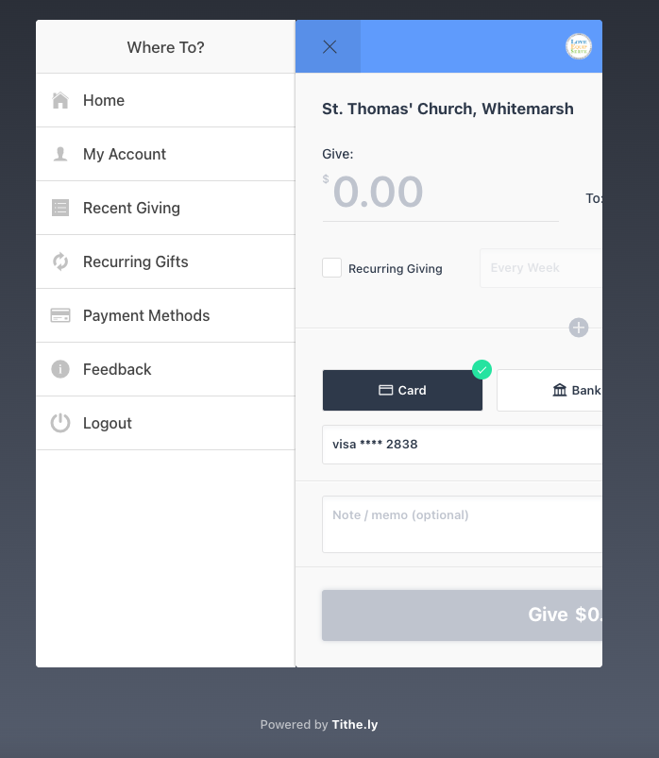

- REFUNDS: If you make an accidental payment, you can process your own refund if you paid with a credit card. When you get your emailed receipt, there should be a tab to process a refund. If you paid with a bank ACH, you will need to email mfoley@stthomaswhitemarsh.org to process it for you.

